ISSUES TO CONSIDER

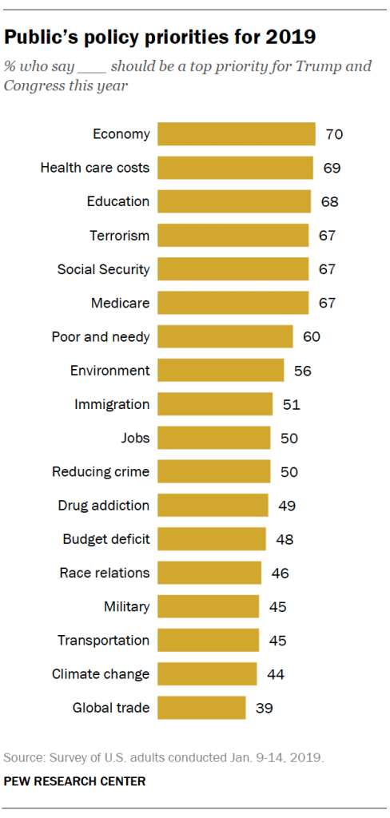
Michigan Voters Issues of Importance
When asked in an open-ended question, “What is the most important issue facing Michigan right now?” The top four responses were:
Roads and bridges | (29.5%)
Jobs and the economy | (18.0%)
Education/education funding | (7.2%)
Water/sewer infrastructure | (6.3%)

https://www.detroitchamber.com/2020policypoll/



