American Rescue Plan

I use a lot of articles from USA Today because it is referred to as the “Nation’s Newspaper.”
You can see that it has a centrist point of view so the coverage is balanced

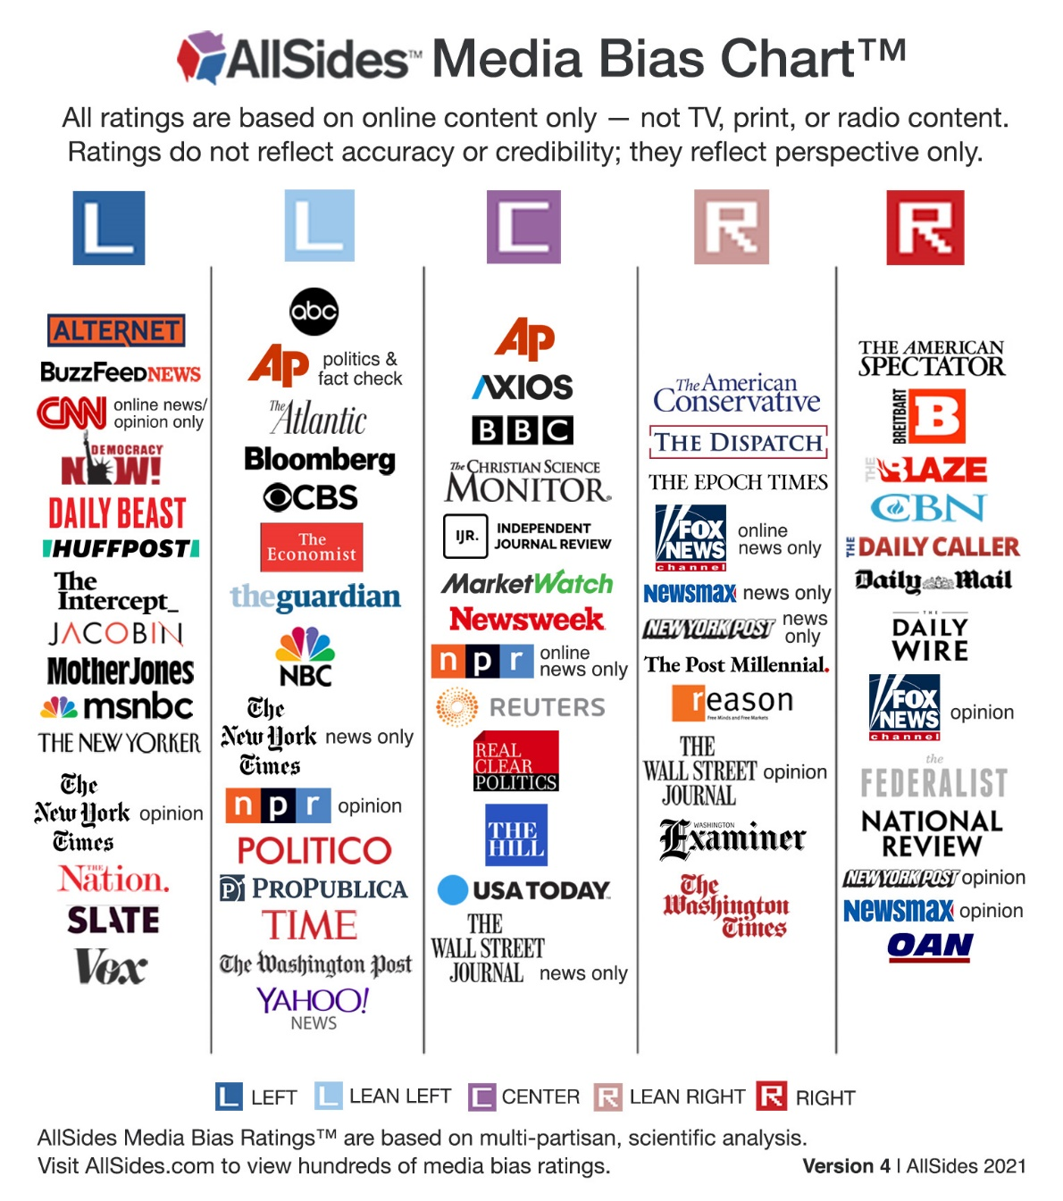

With the economy healing, is Biden's $1.9T COVID-19 relief package too much?
Paul Davidson Michael Collins Charisse Jones USA TODAY FEBRUARY 25, 2021

https://www.usatoday.com/story/money/2021/02/25/covid-relief-bill-stimulus-check-critics-bidens-stimulus-goes-too-far/6804219002/

Americans Support Massive Stimulus Spending
POLLING MATTERS FEBRUARY 12, 2021 BY FRANK NEWPORT
https://news.gallup.com/opinion/polling-matters/329645/americans-historically-support-massive-stimulus-spending.aspx

