Minimum wage articles
I use a lot of articles from USA Today because it is referred to as the “Nation’s Newspaper.”
You can see that it has a centrist point of view so the coverage is balanced
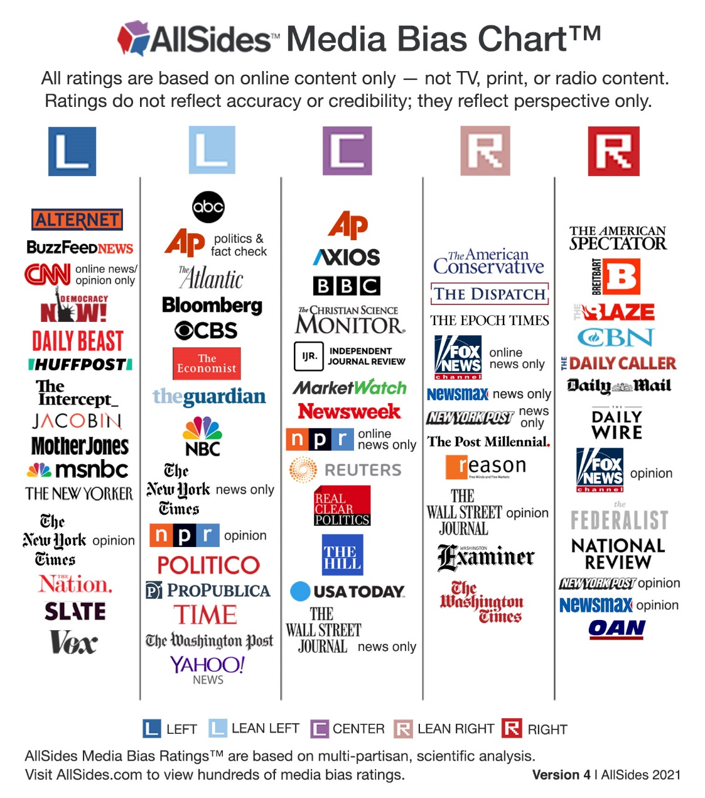

$15 minimum wage would boost pay for millions but would cost 1.4 million jobs, report says

(this was the article I posted on my teacher feed and sent out with the poll through the SLP)
https://eu.usatoday.com/story/news/politics/2021/02/08/government-report-says-15-minimum-wage-would-cost-1-4-million-jobs/4439482001/

Generation Z workers push for $15 minimum wage as Congress, Biden debate pay for all Americans

(this was the article I that I read after the poll went out)
https://eu.usatoday.com/story/news/nation/2021/02/13/minimum-wage-15-pay-law-could-make-difference-gen-z-workers/6720428002/

